Name of organization | International Chamber of Commerce and UNFCCC Business and Industry Constituency
Contact person and contact information for the submission | Sandra Hanni, Global Policy Lead Climate, ICC  UNFCCC Business and Industry Constituency Focal Point  Email: Sandra.Hanni@iccwbo.org
Date | 18 August 2023

ICC and UNFCCC Business and Industry Constituency Submission: UNFCCC Secretariat Recognition and Accountability Framework & Draft Implementation Plan with respect to Net-Zero Pledges of non-State actors and Integrity Matters

The International Chamber of Commerce (ICC) is the institutional representative of 45 million companies in more than 150 countries. Our members include many of the world’s largest companies, small and medium-sized enterprises (SMEs), business associations and local chambers of commerce – working across all sectors around the globe.
ICC has served as the United Nations Framework Convention on Climate Change (UNFCCC) Focal Point for Business and Industry Constituency (hereafter BINGO) since the early 90s and in 2016, was granted Observer Status at the UN General Assembly – the first time a private sector organisation has been admitted formally into the UN system.
ICC is deeply committed to the objective of the Paris Agreement and this commitment was reaffirmed in the ICC Centenary Declaration in 2019, recognising the escalating climate emergency and endorsing the Intergovernmental Panel on Climate Change findings on the urgent need to keep the global temperature increase below 1.5 degrees Celsius.
As global business, we are doing everything in our power to limit global warming to 1.5°C and avoid dangerous tipping points – while also promoting sustainable growth, creating jobs, and ensuring energy security.
More companies than ever before have committed themselves to achieving net zero by 2050 or even before, placing climate at the heart of their business strategies, investments, and operations. This increasingly is the case not just for multinationals and large corporates, but for small and medium size businesses as well.
The significant progress seen within the business community has been possible as a result of business, in all its diversity, being present, learning and engaging in the UNFCCC process, through ICC and BINGO, providing expertise and exchanging with governments and other civil society groups and then conveying key lessons, learnings and success stories in their local contexts.
We recognise that integrity of actions and initiatives from non-State actors, in particular business and financial institutions is more critical than ever and we welcome continued efforts to bring greater transparency and recognition of non-Party stakeholder climate action – that can lead to enhanced voluntary action and can strengthen best practice and guidance around net zero leadership.
In response to the call for inputs and feedback on the UNFCCC Global Climate Action Recognition and Accountability Framework and Draft Implementation Plan with respect to Net-Zero Pledges of non-State actors and Integrity Matters announced on 4 June 2023, ICC would like to offer the following reflections and suggestions with regards to (i) elements contained in the UNFCCC proposal as well as (ii) consultative process.
- Substance: Elements contained in the UNFCCC Recognition and Accountability Framework and Draft Implementation Plan, building in particular on key questions outlined in ICC response letter (see Annex)
Mandate and scope
We are wholly supportive of efforts to bring greater transparency and recognition around climate action by business and all non-State actors and, applaud the UNFCCC Executive Secretary’s dedication as well as Governments’ commitments made at COP27 to amplify the credibility and impact of voluntary non-state initiatives, through enhancing and strengthening the UNFCCC Global Climate Action Portal (GCAP) (originally known as Non-state Actor Zone for Climate Action or NAZCA).
The business community welcomed the launch of the platform in 2014, signalling the solidification of the key role of non-state and sub-national actors in the climate process alongside governments. The portal has been seen as an important tool with great potential to aggregate, catalyse, and showcase climate action and progress by non-State Actors. As it evolved, challenges and difficulties, in particular with regards to low response rate, data aggregation, transparency and interpretation, tracking progress have increased.
Addressing these issues and upgrading the current platform into a robust tool that is capable of attracting existing and future voluntary non-State actors’ commitments and initiatives, keeps compliance burden and related costs to a minimum and provides a platform that business and all non-State actors have full confidence in engaging in, needs to be a first-order priority and should be the focus of the mandate provided by the Parties in Sharm el-Sheikh.
Whilst we recognise that there are some intersections with the recommendations of the High-Level Expert Group on the Net Zero Emissions Commitments on non-State entities, notably recommendation 8 on increasing transparency and accountability – and we are certainly appreciative of the work of the expert group – we consider that effort as separate from and falling outside the mandate provided by Parties.
The UNFCCC proposal and implementation plan should, therefore, focus purely on addressing existing difficulties and finding solutions to enhance and upgrade GCAP. Recommendations of the “Integrity Matters” report should not be taken as a foundation for the work and any efforts to bring them to life in the context of the UNFCCC proposal and implementation plan, clearly lie beyond the mandate from Parties.
Finally, given the mandate’s focus on building a strengthened GCAP portal and a more transparent, robust data base and also to provide more clarity to the public on the nature and objective of the planned work, we recommend that the Secretariat considers renaming its proposal and implementation plan “UNFCCC Recognition of Enhanced Transparency and Draft Implementation Plan for an Enhanced Global Climate Action Portal for non-Party stakeholder climate action”.
Whilst we understand that there is accountability for compliance with legal rules and mandatory regulation, the concept is often understood with a connotation of applicability to entities regarded as untrustworthy and to be treated as guilty until proven innocent. Given the voluntary nature of the platform and the mission to attract an increasing number of initiatives and entities, we believe that enhanced transparency and transparency of information are the more appropriate terms to use in this context.
Transparency of information and data
Better information and data of non-State actor climate action can guide and inform climate policy and action and can help build trust among stakeholders. Priority should be given to identifying appropriate solutions to increase transparency of information and data provided through GCAP.
As such, it is imperative to better understand the nature and extent of current progress reports required by GCAP, as well as already established and planned partnership with reporting and disclosure platforms, such as CDP, the Climate Data Steering Committee and the Net-Zero Data Public Utility.
Any additional burden/complexity for entities, that are already reporting to voluntary domestic or international initiatives must be avoided. Progress reports should be based solely on existing voluntary reporting frameworks and initiatives. Coalitions and alliances’ existing science-based norms for target-setting and progress reporting should be taken into account and where applicable, initiatives and individual entities, that are not already reporting to an existing platform, may refer to one of the existing initiatives.
Validation and Verification
Robust monitoring, reporting and verification (MRV) frameworks are a cornerstone underpinning and facilitating impactful climate action across the globe. Such systems, if developed and implemented effectively, can encourage transparency, accountability and trust between all stakeholders and can provide a high degree of assurance to the public that efforts to combat climate change are yielding the expected results.
In this regard, we welcome and support the important existing work done and under development by national governments and different international organisations, that will also take into account and have an impact on non-State actor climate action and commitments.
Parties under the Paris Agreement committed to transparency of action and support as a central component of the Accord, agreeing to also establish an Enhance Transparency Framework (UNFCCC, 2015c, Article 13) and important additional components and provisions for the review of contributions, including Article 14 on the global stocktake to be undertaken every five years to assess collective progress.
Transparency through robust MRV processes is also pivotal to ensure environmental integrity under the market mechanisms defined under Article 6 of the Paris Accord, where MRV systems and methodologies are currently being developed. In addition to the existing rules in place under national and subnational compliance systems, efforts have been advanced in the voluntary carbon market, such as by Integrity Council for the Voluntary Carbon Market (ICVCM) and the Voluntary Carbon Markets Integrity Initiative (VCMI), to provide a credible and rigorous means of identifying high-integrity carbon credits that create real, verifiable climate impact, based on the latest science and best practice.
The UNFCCC Secretariat’s aim should, therefore, not be centred on creating an additional, new reporting/disclosure framework, nor to become a third-party verifier for non-State actors voluntary actions and commitments but rather leverage and promote existing efforts at national and international level and most importantly under the different provisions of the Paris Agreement, including Article 6 and Article 13.
Timelines
Given the complexity and scale of the work planned as well as the urgent need for close consultation and dialogue with business and all non-State actors on all aspects in the development and implementation of the UNFCCC effort to enhance the GCAP portal, we believe that it will be quite challenging to achieve a workable outcome within the current set timeline.
We therefore encourage the Secretariat to revise the proposed timeline accordingly and allow for sufficient time for consultations and dialogue with business and non-State actors at each stage of the process.
Governance and Resourcing
With regard to the various oversight/verification groups envisioned in the UNFCCC proposal, the need for and purpose of such groups should be carefully assessed and evaluated. It will be important to provide further clarity on the mandate of these groups, their governance and composition. Any such group should include and engage experts from civil society, and in particular the private sector.

We recognise that this effort presents the Secretariat with a daunting task, that requires sufficient financial and staffing resources. We welcome the draft decision on administrative, financial, and institutional matters adopted during the Bonn Intersessional Meeting in June 2023 that confirms allocation of new funding and staff for the enhancements to the global climate action portal in close collaboration with Parties and non-Party stakeholders.

Providing full clarity and transparency with regards to additional resources and funding provided to the project as well as where and how this funding will be allocated, in particular funding received from a variety of philanthropic sources for the first phase of this work will be important.

- Process: how the consultation should happen and who needs to be engaged
The announcement of the UNFCCC Secretariat Recognition and Accountability Framework and Draft Implementation Plan has caused a significant degree of uncertainty and concern across a broad range of the business community. This is due notably to the lack of engagement and consultation with the private sector in the early phase of the development of the UNFCCC initiative.
It is therefore imperative to establish a deep, meaningful and inclusive dialogue with the private sector and all non-Party stakeholders over the coming months and engage them in the development of all elements and steps of implementation of an Enhance Global Climate Action Portal.
We truly welcome the commitment to establish an inclusive and consultative process to receive stakeholder input on the expected outcomes. Such a process should be at the centre of the UNFCCC initiative and should be held prior the start of any work planned by working groups or oversight bodies. Consultations should be held in the form of informal consultations and should focus on individual provisions and elements contained in the proposal.
We further recommend the establishment of a business consultative group of representatives of different sectors and jurisdictions, that in close collaboration with the co-chairs of the UNFCCC engagement process, will help test and assess suitability, workability and applicability of specific elements and provisions.
Outcomes from informal consultations and expert advice provided by the consultative group should be captured in the form of informal documents and should be reflected in the co-chairs recommendations to the UNFCCC Executive Secretary.

We trust that the above feedback and contributions will be helpful in defining appropriate next steps and establishing a process in which the private sector and all stakeholders have full confidence and trust. We remain committed to working with the UNFCCC Secretariat, all Parties and stakeholders to build an Enhanced Global Climate Action Portal that can spur voluntary leadership initiatives and action.

Annex
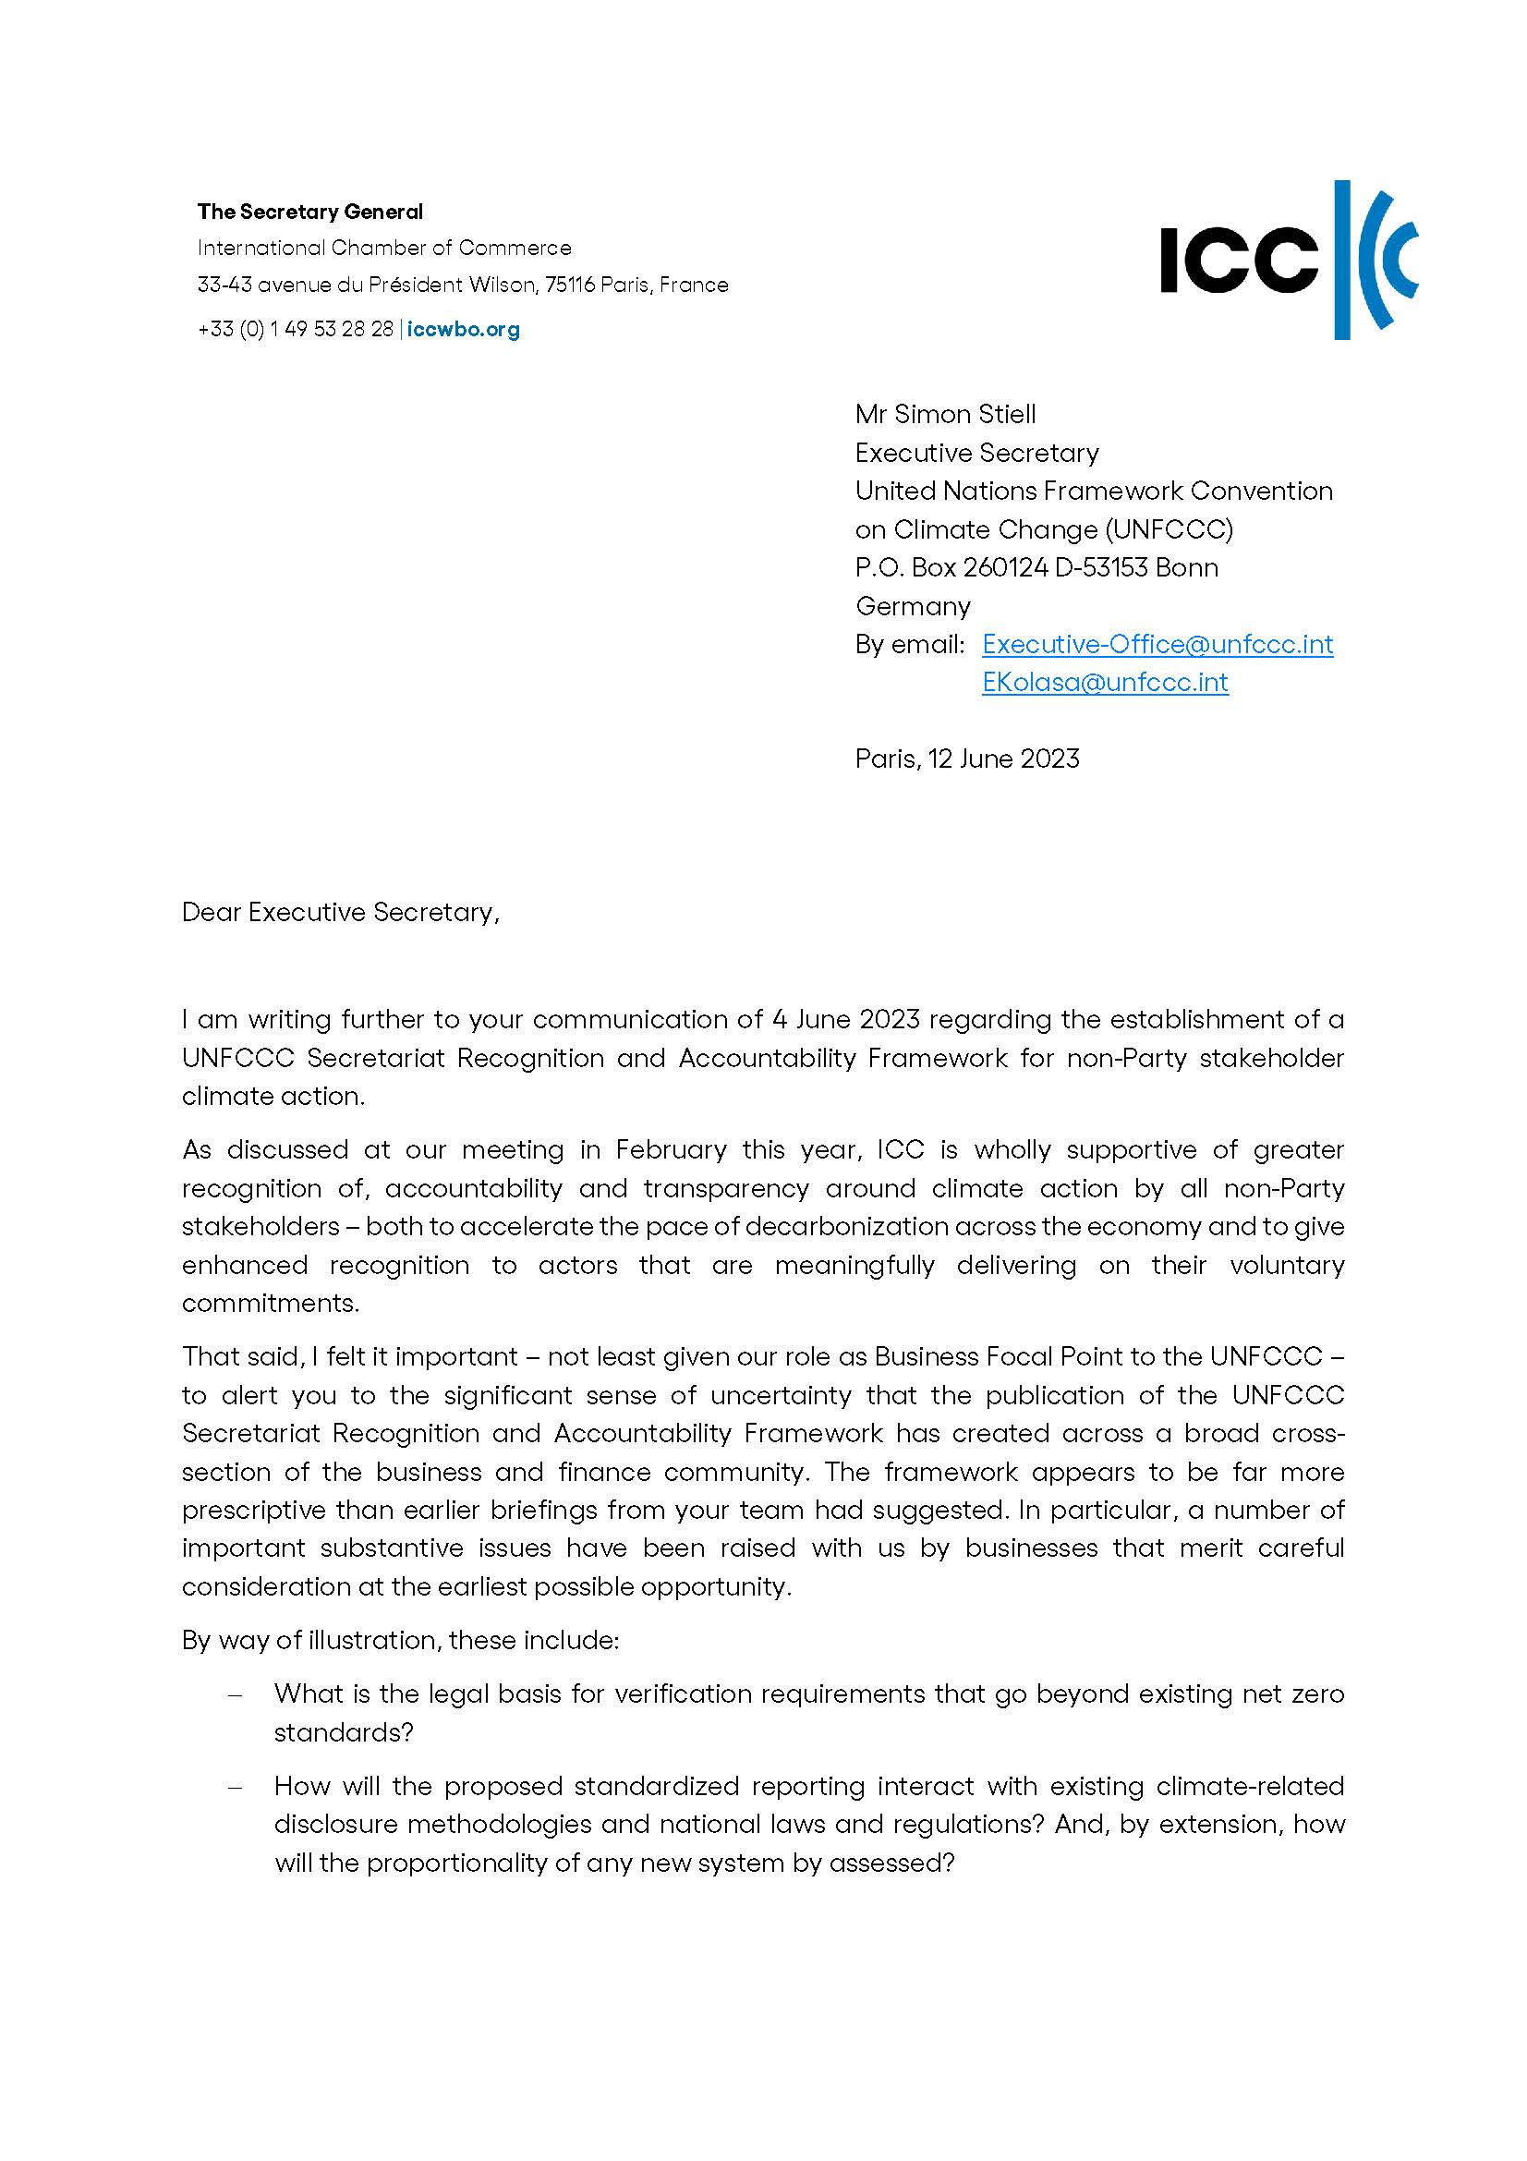

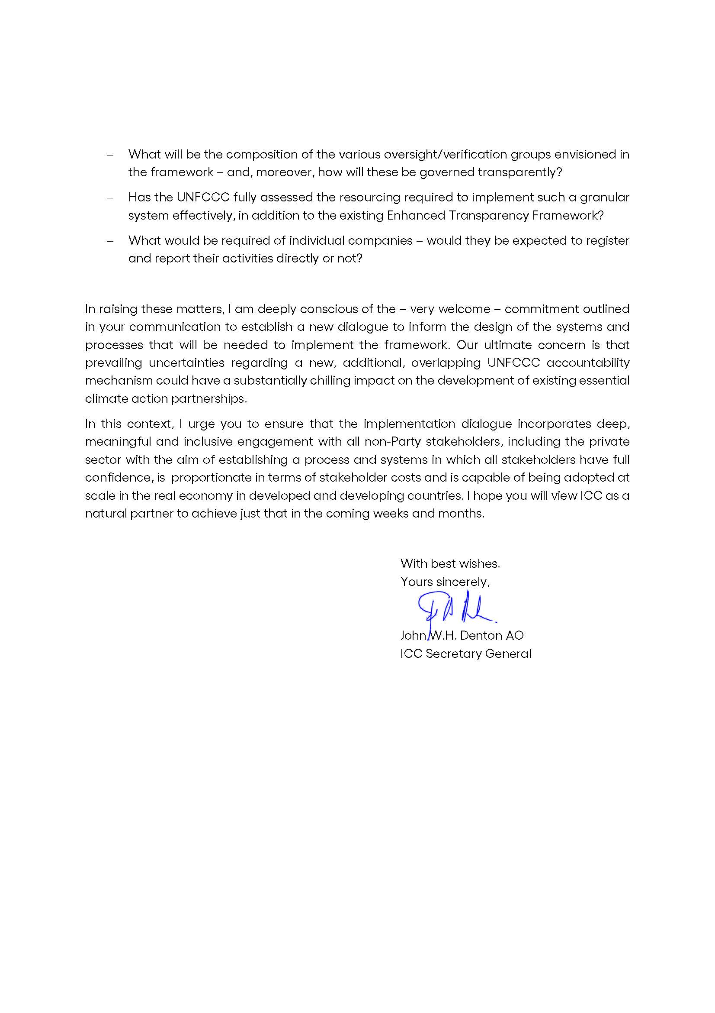

ICC Declaration on the Next Century of Global Business https://iccwbo.org/news-publications/policies-reports/icc-centenary-declaration/
Decisions 1/CP.27 and 1/CMA.4 taken respectively by the Conference of the Parties to the UNFCCC and the Conference of the Parties serving as the meeting of the Parties to the Paris Agreement in Sharm el-Sheikh in November 2022

